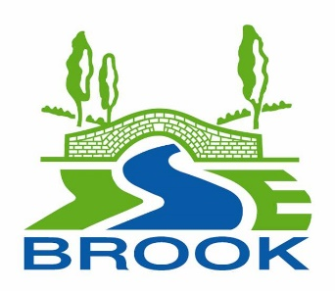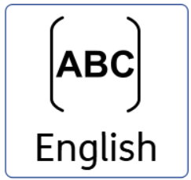
Subject Intent statement
At Isebrook, we believe that every student has the right to learn how to communicate, read and write. We recognise that reading, writing, speaking and listening is not solely attributed to one group of individuals or a single subject such as English. Throughout our entire curriculum, we aim to develop these skills across a range of situations that will prepare our students for life beyond Isebrook.

We aim to deliver an inspiring and engaging English curriculum through high quality teaching and exciting lessons.

Communication is the key to a fulfilling life. We want our students to have a positive attitude towards communication and to be able to independently express their needs, wants and ideas. In addition to this, we strive to provide our students with the skills to progress to the next steps in their learning journey i.e., post 16 education.

Subject specific Implementation
Pathway 1 | Pathway 2 | Pathway 3 | Pathway 4
- Communicate In Print - symbols  - Visuals  - Social Stories  - Colourful Semantics  - Concrete objects  - Repeated Routine  - Signing- Sign Along  - SALT Interventions  - OT Interventions  - Literacy Interventions  - Phonics  - Sight Reading  - Talking Tins  - ICT Games  - Bug Club  - Read, Write Inc  - Communication Boards - word mats  - Phase 2,3 words  - Individualised work – working on EHCP targets  - Mind mapping  - Guided Reading  - Skills Builder  - Toe by Toe  - Word Wasp | - English Working Wall  - Word Wizard (Word Aware)  - SALT  - Guided reading  - Reading VIPERS  - Talk for Writing  - Communicate In Print – symbol  - Talking Tins  - Bug Club and Accelerated Reader  - Phonics  - Guided reading  - Vernon Spelling Test  - Read, Write Inc  - Toe by Toe  - Word Wasp  - Colourful Semantics  - EHCP Targets  - Skills Builder  - Sign along | - BBC Bitesize revision online  - Entry Level 2 and 3 Functional Skills word lists  - Dragon pens  - iPad tools for reading and writing  - Colourful Semantics  - Working Walls  - Word Mats  - Bug Club and Accelerated Reader  - Guided Reading  - Word Aware  - Communicate In Print – symbol  - Talking Tins  - STAR Reader assessment  - Vernon Spelling Test  - SALT  - EHCP Targets  - Skills Builder  - Toe by Toe  - Word Wasp | - GCSE Framework  - Quotation banks  - GCSE Terminology banks  - Working Walls  - Talking Tins  - Functional skills framework  - Functional Skills word lists  - Genre word banks and communication mats  - Essay frame works  - Word Aware  - Word of the Week  - Talk for Writing  - Bug Club and Accelerated Reader  - Guided Reading  - STAR Reader assessment  - Vernon Spelling Test  - Colourful Semantics  - Speaking Frames  - Individual reading  - Spelling lists  - BBC Bitesize revision online  - Group Reading  - EHCP Targets  - Skills Builder
Subject Impact

The impact on our students is clear: progress, sustained learning and transferrable skills. Students will progress to the next level of their learning journey with the necessary skills to achieve their full potential.
They will be able to communicate clearly using an appropriate method of communication which will enable them to become integrated members of society.

